Module A.1: Simon Icebreaker

Daniel Gopal

Level 0: Play the Simon game

Game-play items

1. 7
2. 11
3. Simon allows us to memorize patterns in which can be some form of learning while also having a fun and good time.
4. Simon is similar to digital games such as bounce as both require memorization of patterns.

Technical items

1. You must tap the correct colour by which the flashing lights will indicate.
2. It gives a buzz if we had done something wrong meaning you have lossed or plays a ring if you had proceeded through the pattern correctly.
3. Solo and pass it mode
4. That you got the pattern wrong.

Level 1: Simon History

Research

1. Ralph Baer
2. Simon was named after Simon Says
3. Magnavox Odyssey
4. Games such as Ping Pong, Table Tennis, and Volleyball

Discuss

1. The Super Nintendo (SNES)
2. Current games intend to have better graphics and gameplay mechanics from the innovation of better game engines.
3. Most of the time all have a storyline and gameplay structure similar to one another like for example if I was playing Mario I would still have to run around and jump on Goombas and Koopas.

Level 2: Output Analysis

1.

|  |  |  |
| --- | --- | --- |
| **Object** | **Action** | **Description** |
| Red Button | Push | Starts the game |
| Red Button | Push | Record a step in the pattern |
| Green button | Push | Continues the pattern |
| Blue button | Push | Game selector  Skill level |
| Yellow button | Push | Ends game |
|  |  |  |

2.

|  |  |  |
| --- | --- | --- |
| **Object** | **Action** | **Description** |
| Red light | Flash | Indicates step in the pattern |
| Red Sound | Play tone | Indicates a step in the pattern |
| Green light | Flash | Indicates step in the pattern |
| Green sound | Play tone | Indicates step in the pattern |
| Blue light | Flash | Indicates step in the pattern |
| Blue sound | Play tone | Indicates step in the pattern |
| Yellow light | Flash | Indicates step in the pattern |
| Yellow sound | Play tone | Indicates step in the pattern |

3.

|  |  |  |
| --- | --- | --- |
| **Object** | **Action** | **Description** |
| Red button | Red Light | Flashes when button is pushed |
| Green button | Green light | Flashes when button is pushed |
| Blue button | Blue light | Flashes when button is pushed |
| Yellow button | Yellow light | Flashes when button is pushed |

Level 3: Flowchart Conventions

1.

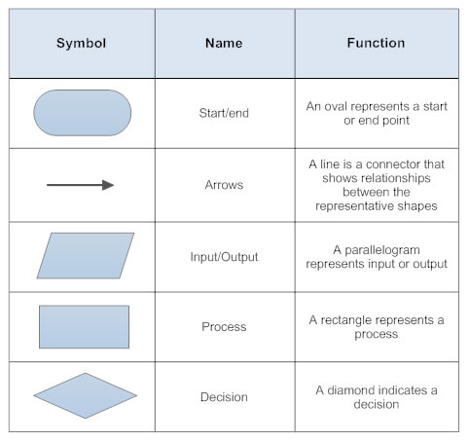

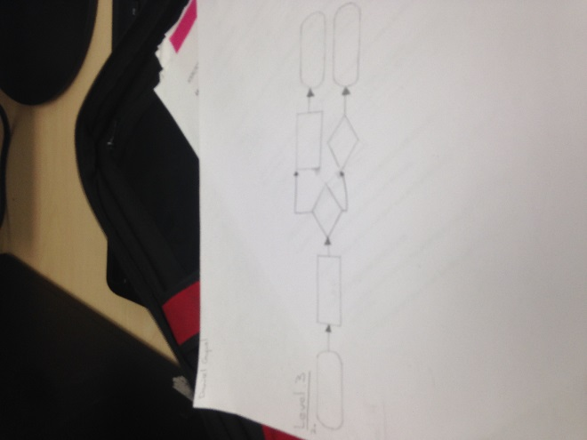2.



Was the decision correct?

Level 4: Flowchart the Simon game

1.

Flash

Start



Flash

Push

End

Was the decision correct?

Flash

End

Push

2.

Game sends input/ output

Game plays pattern



Adds colour

Creates pattern of colours



Start

Was the decision correct?

End